SYNOPSIS

Of

**Blood Bank Management**

**SUBMITED TO:- SUBMITTED BY:-**

**INDEX**

* **COMPANY PROFILE**
* **Django INTRODUCTION**
* **CHARACTERSTICS**
* **INTRODUCTION ABOUT PROJECT**
* **PROJECT MODULES**
* **ABOUT TRAINING**
* **HARDWARE AND SOFTWARE TO BE USED**
* **SCOPE OF WEBSITE**

**COMPANY PROFILE**

INFOWIZ is leading strategic IT Company offering integrated IT solution. INFOWIZ is having rich experience managing global clients across various business verticals and align IT strategies to achieve business goals. The various accreditations that we achieved for every service, we offer reflect our commitment towards the quality assurance.

**INFOWIZ is a 10 years** young organization with **an ISO Certification** & a member of Confederation of Indian Industry (**CII membership number – N4654P** ) . We also provide the off shore companies of US, UK, France, Ireland, Canada and Australia with quality and timely Web and SEO services.

INFOWIZ is an organization which is established in the field of Web Development (PHP & .NET), JAVA (Core as well as Advance), I-phone & Android Applications, Embedded systems (AVR, PIC & ARM), ROBOTICS and Networking (MCSE, CCNA & RHSE), Mechanical Engineering (CRDi, CATIA, VVT, VCR, ABS, CRUISE CONTROL, PRO-E, SOLID WORKS).

Our skilled team of professionals make sure that the product is developed as per the customer’s needs and keeping the customer informed about the development of their project from time to time. We do not only emphasize on formulating an attractive solution to our clients but also believe in providing a workable solution. INFOWIZ offers research based Search Engine Marketing products that help achieve greater insights to customer’s online business. Our Research & Development arm offers SEO tools for SEM professionals.

INFOWIZ also provides **Technical Support & Consultancy** to Software Companies like JIA Group, Newzealand, Sagitech solutions Panchkula, Jarcinfotech Mohali, Infonet SolutionDelhi,web it solutions, Speedinforays etc. **Our Hottest Clients & Projects:-**

**PROJECTS URL’s COUNTRY**

1.)Viva Sales www.[**infowiz.in/vivasales**](http://infowiz.in/vivasales) UK

2.)Mds Creative [www.mdscreative.com](http://www.mdscreative.com) Germany

3.)Liddle TV www.filmon.com UK

4.)Paradigms(Android) running Australia

5.)Printcost www.popgraphics.net UK

6.)PSTDO Bootstrap www.bootstrap.achiever.com USA

7.)Essencesoftwares www.essencesoftwares.com Australia

8.)Dashboard(Wordpress) running USA

9.)Realstate [www.realestate.infowiz.in](http://www.realestate.infowiz.in) Russia

10.)Dealpartners(WordPress) [www.dealpartners.co.uk](http://www.dealpartners.co.uk) UK

11.)Littletonvineyard www.littletonvineyard.net USA  
 12.)Gpakoffshore www.gpakoffshore.com UK

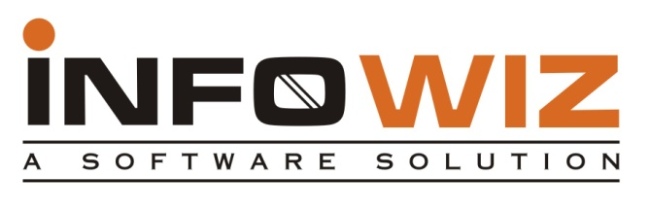

**COURSES Offered :-**

**For CSE/IT/MCA Professionals:-**

1. Web Development in PHP with LIVE Projects
2. Web Development in .NET with LIVE Projects
3. Full Stack Development in Django/MERN/MEAN
4. JAVA (Core as well as Advance ) with LIVE Projects
5. Android Applications with LIVE Projects
6. Web Designing (Photoshop, Coral Draw)
7. C#, Console Applications, VB.NET, ASP.NET
8. MySQL, SQL, ORACLE
9. Networking (MCSE, CCNA, RHSE)
10. SEO (Search Engine Optimization)

**For ECE/EE/EIE Professionals:-**

1. Robotics With Live Project
2. VLSI-VHDL with Live Project
3. Embedded System Design with Live Project
4. Microcontroller with Live Project
5. Microprocessor with Live Project
6. PCB Designing
7. AVR & PIC Family
8. PCB and layout designing
9. AUTOMATION with Live Project

10.) Project development with ARM processors

**For ME/ECE Professionals:-**

1. CRDi Technology
2. ABS, CRUISE CONTROL.
3. MPFi&EFi Technology
4. CATIA
5. PRO-E
6. AUTOCAD/CAM
7. SOLIDWORKS

Our core strength is our timely, technically and cost effective project delivery. We also provide customers with designs as per their demands. INFOWIZ also provide Industrial Training of 6 Months & 6 Weeks in ME / IT & Electronics to B.Tech, MCA students. We help students in building their career.

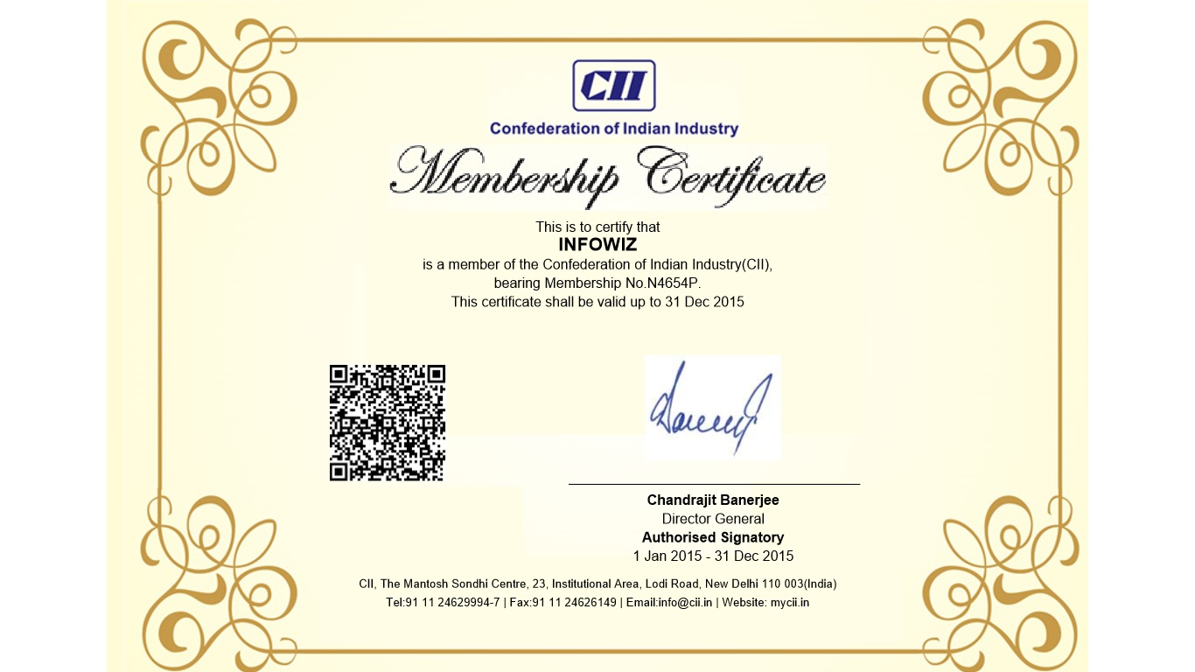

**Django Introduction**

The Django web framework is a free, open source framework that can speed up development of a web application being built in the Python programming language. Django facilitates “rapid development and clean, pragmatic design.” The Django web framework, deployed on a web server, can help developers quickly produce a web frontend that’s feature-rich, secure and scalable.

Starting with the Django web framework is more efficient way to build a web app than starting from scratch, which requires building the backend, APIs, Javascript and sitemaps. With the Django web framework, web developers can focus on creating a unique application and benefit from greater flexibility than using a web development tool.

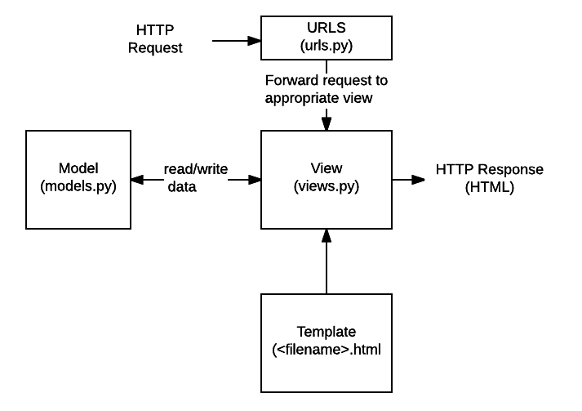

**INTRODUCTION TO PROJECT**

**Blood Connect:** This project is aimed to developing an online Blood Information in this Project we can collect an information about the donor, receiver and camp that are related to donating, receiving the blood. Through this application any person who is interested in donating the blood can register himself and in the same way if any camp wants to register itself with this site that can also register. Moreover if any general consumer wants to make request blood online he can also take the help of this site. Admin is the main authority who can do addition, deletion, and modification if required.

**MODULES:**

1. **User**
2. **Blood Donor**
3. **Blood Requisite**
4. **Camp**
5. **Admin**

**1. User**

The new user can register itself to site by filling the registration form.

**2. Blood Donor**

A single donation from you can help one or more patients. You can register yourself as donor by filling the form.

**3. Blood Requisite**

If you want to take blood you can submit the requisite form mentioning the units of blood needed.

**4. Camp**

Through this you can add new camp along with the venue and expected date on which camp to be held.

**5. Admin**

Admin is having authority of adding, viewing and deleting any blood bank and camp.

**ABOUT TRAINING :-**

During our training we have study about

* **Introduction of HTML.**
* **DHTML**
* **CSS**
* **JAVASCRIPT**
* **Python Basics**
* **Django**
* **DB SQlite**

**Software and Hardware Requirements**

**Hardware Specification**

Processor : Pentium III/AMD Athlone XP

RAM : 128 MB

Hard disk : 20 GB

FDD : 1.44MB

Monitor : 14 inch

Mouse : 3 Button scroll

CD Drive : 52 X

Keyboard : 108 keys

**Software Specification**

Operating System : Windows 2007

Languages : Basics of Python, Django Framework

Front End : HTML, JavaScript

Web Servers : WSGI

Backend : DB SQLite

Browser Program : Internet explorer/Chrome

**Scope for Future Enhancement**

In future we can use Image recognition instead of using heterogeneous database more over High speed, accuracy and non-redundant data are the main advantages of the proposed system. In the proposed system the user is provided with a choice of data screen, which are similar in formats to the source documents. Data entry errors can be minimized through validity checks. After the verification only the data are placed the permanent database. The software can be developed further to include a lot of modules because the proposed system is developed on the view of future, for example we should develop the system as a database independent using JDBC so we can connect it to any other database, Now the proposed system is based on PC and intranet but in the future if we need to convert it into internet then we need to change the front end only because we are developing this on the basis of OOP technology and most of the business logic’s are bounded in the class files and module like reusable components.